**Integrated Multi-Trophic Aquaculture (IMTA)**

Integrated multi-trophic aquaculture, or IMTA, is similar to polyculture, where two or more organisms are farmed together. In IMTA, multiple aquatic species from different trophic levels are farmed in an integrated fashion to improve efficiency, reduce waste, and provide ecosystem services, such as bio-remediation.

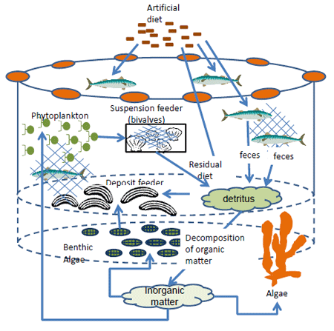

**Fig: IMTA nutrient transformation system**

IMTA is the practice which combines the cultivation of fed aquaculture species (e.g. finfish/shrimp) with organic extractive aquaculture species (e.g. shellfish/herbivorous fish) and inorganic extractive aquaculture species (e.g. seaweed) to create balanced systems for environmental sustainability (biomitigation) economic stability (product diversification and risk reduction) and social safety.

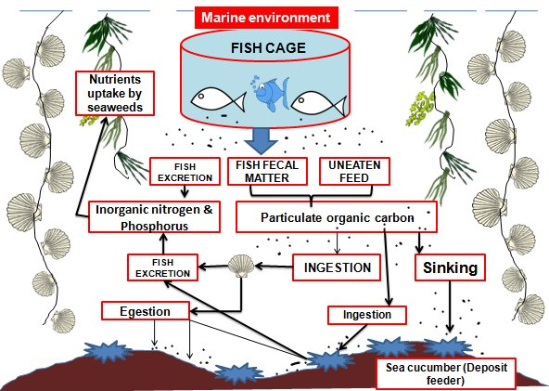

Principle of IMTA

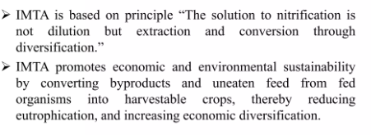

System design for IMTA

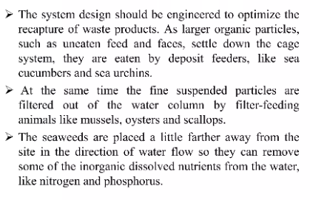 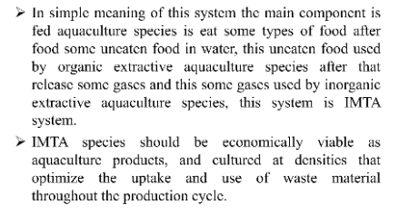 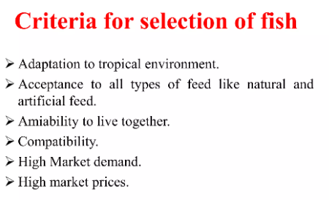

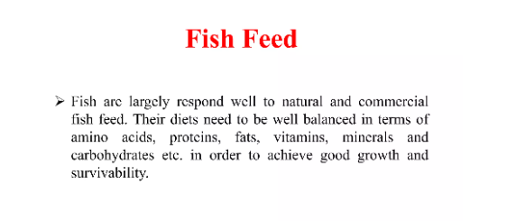

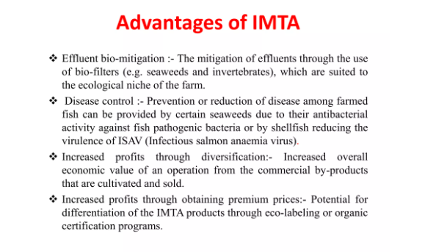 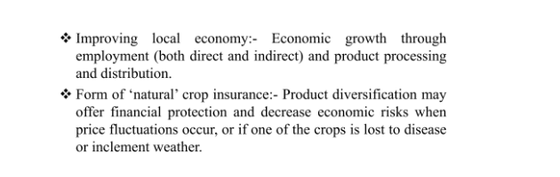

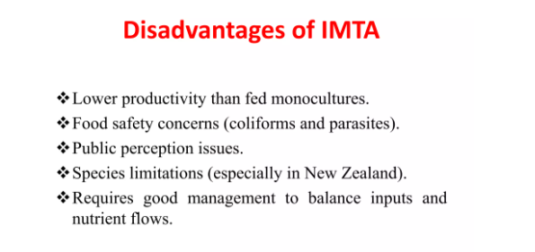

**Integrated floating cage aqua geoponics system (IFCAS)**

The Integrated Floating Cage Aquageoponics System (IFCAS) was developed as an [aquaculture](https://en.wikipedia.org/wiki/Aquaculture)-horticulture based on the concept of [integrated farming](https://en.wikipedia.org/wiki/Integrated_farming) system approach firstly in [Bangladesh](https://en.wikipedia.org/wiki/Bangladesh) in 2013 to produce fish and vegetables in floating condition where waste materials (fish [feces](https://en.wikipedia.org/wiki/Feces) and unused [feed](https://en.wikipedia.org/wiki/Animal_feed)) from fish culture dissolved in the pond water and settled on the bottom mud are used for vegetables production.

**Development process of IFCAS**

Filling the gap of supply and demand of fish and vegetables for improving household nutrition, the ANEP ([Agriculture and Nutrition Extension Project](https://en.wikipedia.org/w/index.php?title=Agriculture_and_Nutrition_Extension_Project&action=edit&redlink=1)) funded by the [European Union](https://en.wikipedia.org/wiki/European_Union) (EU) works in [Barisal District](https://en.wikipedia.org/wiki/Barisal_District) of [Bangladesh](https://en.wikipedia.org/wiki/Bangladesh) following an integrated aquaculture-agriculture approach. Pond [dykes](https://en.wikipedia.org/wiki/Levee) in Barisal are commonly used for planting trees by the rural people which provide cooking [fuel](https://en.wikipedia.org/wiki/Fuel), fruits, and timber for sale. Trees on the pond dyke create [shadow](https://en.wikipedia.org/wiki/Shadow), which reduce [sunlight](https://en.wikipedia.org/wiki/Sunlight) penetration to the edges of the pond and the dykes. In this context, IFCAS was developed in the shaded ponds without changing the vegetative nature of pond dykes following the collegial principles of action research.

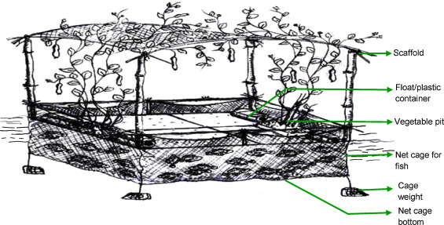

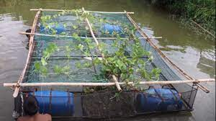

**Technical aspects**

1. A 9 m2 rectangular iron-bar made structure was constructed, having four [concave](https://en.wiktionary.org/wiki/Special:Search/concave) grooves in its four [corners](https://en.wiktionary.org/wiki/corner) for holding floats of plastic drums.
2. The whole bottom of the structure was surrounded by a rectangular nylon [net](https://en.wikipedia.org/wiki/Net_(device)) [cage](https://en.wikipedia.org/wiki/Cage_(enclosure)) with the dimensions of length-3.66 m × width-2.44 m × depth-1.25 m.
3. Under the four corners and middle points of the net, half-brick weights were hung to ensure that the net retained a rectangular structure under the water.
4. In the middle of both widths of IFCAS, two pits filled with dried pond mud of the same pond are used as medium for vegetable [plantation](https://en.wikipedia.org/wiki/Plantation).
5. On the top of the structure, a [scaffold](https://en.wikipedia.org/wiki/Scaffold) was made using split [bamboo](https://en.wikipedia.org/wiki/Bamboo) and net for vegetables to [climb on](https://en.wikipedia.org/wiki/Tendril).

**Advantages of IFCAS**

Following benefits in this system is discussed below:

* **Better then Aquaculture technique**: Compared to other [aquaculture](https://en.wikipedia.org/wiki/Aquaculture) technology, IFCAS showed several benefits to the adopting farmers.
* **Good relationship between fish and plants**: Like traditional [aquaponics](https://en.wikipedia.org/wiki/Aquaponics" \o "Aquaponics), fish and plants also rely on each other in aquageoponics. Here a mutual relationship exists between fish and plants. Unused fish feed and excrements result in nitrogenous wastes in the pond water and mud what are used as nutrients (nitrate) by the plants in IFCAS.
* **Proper management of unused vegetation**: Here some substrates such as, fallen leaves from horticulture plants, mud and materials in IFCAS (such as drums, iron plates etc.) harbour the nitrifying bacteria what convert toxic [ammonia](https://en.wikipedia.org/wiki/Ammonia) to less harmful [nitrate](https://en.wikipedia.org/wiki/Nitrate).
* **Effective nutrient absorption by root**: Plant roots hanging from IFCAS pits, absorb [nutrients](https://en.wikipedia.org/wiki/Nutrients) more effectively from water than plants do in traditional [soil](https://en.wikipedia.org/wiki/Soil) based agriculture as roots are longer and healthier in IFCAS. Like in aquaponics, plants grow faster in IFCAS also. Moreover, symbiotically plants facilitate by providing fish with ammonia free water in return.
* **Easy harvesting of products**: Harvesting fish and vegetables from IFCAS is very easy for both men and women. Apart from consumption of fish and vegetables at the household level, farmers earned money by selling fish from IFCAS. IFCAS is not only useful in the small shaded ponds but also in multi-ownership ponds, state-owned ponds, natural water bodies (beel), rivers, canals, and the waterlogged areas affected by climate change.

Along with dissemination of this technology in Bangladesh, IFCAS has been trialed in ponds in [Nepal](https://en.wikipedia.org/wiki/Nepal) which was found encouraging for nursing [fish fingerlings](https://en.wikipedia.org/wiki/Juvenile_fish) and vegetables during [dry season](https://en.wikipedia.org/wiki/Dry_season).